Newsletter – January 2019
Induction Programme for Students
The chapter organised an Induction Programme for the students on 20 January 2019 at the Chapter premises. CS. Jayan K, former Chairman, Kochi Chapter led the session. The programme covered the detailed scope of CS profession and provided a road map for CS students, followed by and interactive session. 7 members and 47 students attended the programme.
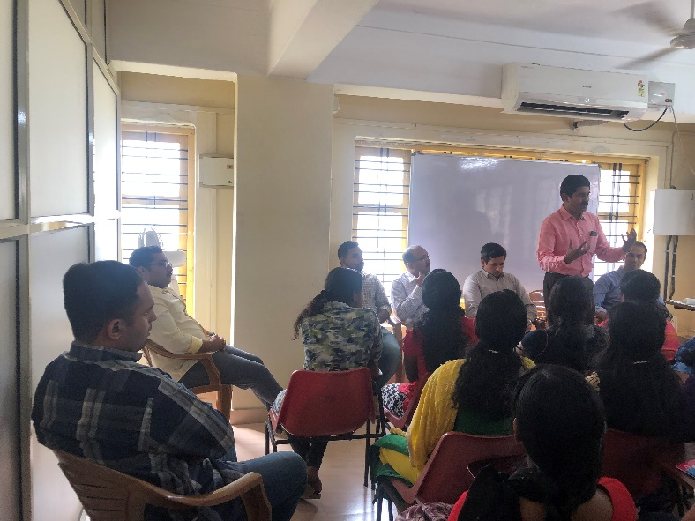 | 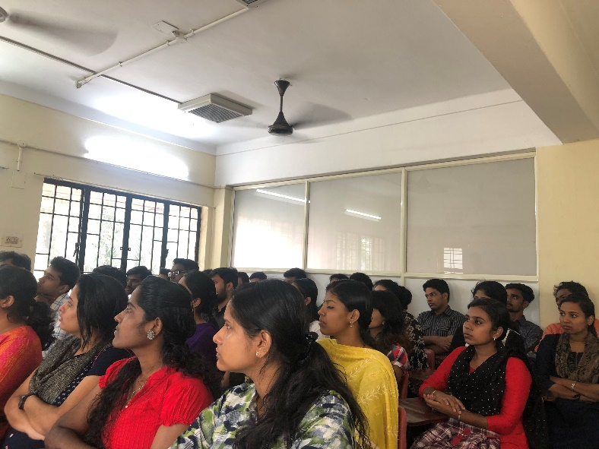

Republic Day celebrations
The chapter hosted the 70th Republic Day Celebrations at its premises. CS. Asish Mohan, Chairman of the chapter hoisted the flag. CS. N Balasubramanian, Secretary, SIRC graced the occasion and addressed the members and students. The senior members present addressed the attendees and highlighted the relevance of hosting similar programmes and participation thereto. A green protocol was observed throughout the programme, which was attended by 22 members and 13 students.
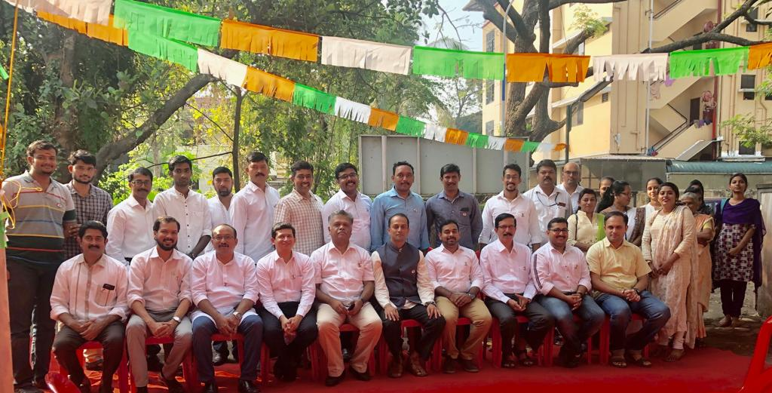

Visit to the Office of Registrar of Companies and Official Liquidator
The Managing Committee representatives visited the office of Registrar of Companies, Kerala and met Mr. Prasanth V, Deputy Registrar of Companies, Kerala. The representatives also met Mr. S Chandrasekharan, Official Liquidator (Kerala). The team discussed on some joint programmes, beneficial to the students and proposed to host interactive sessions so as to enable the students understand the functioning of the said offices.
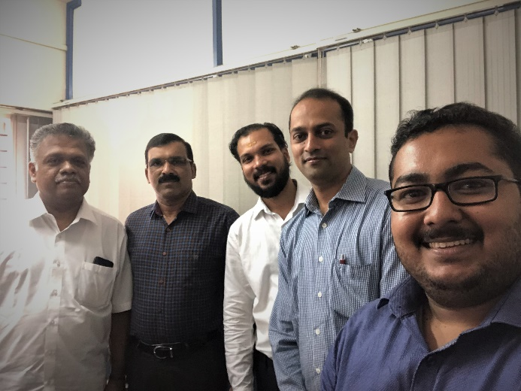 | 