FREQUENTLY ASKED QUESTIONS ON e-FORM ACTIVE

Q.1. What is E-form ACTIVE?
ACTIVE stands for Active Company Tagging Identities and Verification. The Ministry of Corporate Affairs has introduced the same for address validation of Active companies.
Q.2. What is the applicability of the form?
The form is applicable to every company incorporated on or before the 31st December, 2017. Such companies shall file the particulars of the company and its registered office, in e-Form ACTIVE (Active Company Tagging Identities and Verification) on or before 15.06.2019
Restrictions on filing the Form:
Any company which has not filed, with the Registrar, its
a due financial statements under section 137 or
b due annual returns under section 92 or
c both(a) and (b)
However, if there is a management dispute due to which such company has not been able to file financial statements and returns under section 137 and section 92 and the same has been intimated and recorded by the Registrar, such companies may file e-form ACTIVE.
Exemptions
Following companies are not required to file E-form ACTIVE
- Companies struck off/ under process of striking off
- Companies under liquidation
- Companies which are amalgamated or dissolved
as recorded by the Registrar.
Q.3. What is the fee for filing E-form-INC- 22A?
According to Companies (Registration Offices and Fees) Amendment Rules, 2017, there is no fee payable by the company for filing INC-22A on or before 15.06.2019 thereafter in delayed cases i.e. filing of e-form on or after 16.06.2019, Rs. 10,000 is payable.
Q.4. What will happen if the company does not file E-form INC-22A?
Such Company shall be marked as ‘ACTIVE non-compliant’ and shall not be eligible to file the following forms:
- SH-07 (Change in Authorized Capital)
- PAS-03 (Change in Paid-up Capital)
- DIR-12 (Changes in Director except for cessation)
- INC-22 (Change in Registered Office)
- INC-28 (Amalgamation, de-merger)
However, the company shall be marked as ‘ACTIVE Compliant’ on filing of e-form ACTIVE with specified fee.
Q.5. In respect of filing of e-form Active pursuant to the Companies (Incorporation) Amendment Rules 2019, please confirm whether companies which are already under the process of amalgamation (yet to be amalgamated) are required to file e-Form Active.

Following Companies are exempted For Filing the e-form ACTIVE (INC-22A)

(a) Companies which have been struck off
(b) Company under process of striking off
(c) Company under liquidation
(d) amalgamated or dissolved
Q.6. Whether two companies can use the same premises as registered Office?

As per Companies Act, 2013 nowhere limit of registered office at single premises is prescribed. Therefore, it is very clear that single premises can have any number of registered offices.

Q.7. Many Government Companies did not file ADT-1 as no approval in AGM is required for appointment; no details in such cases appear in prefill. Explain?

No exemption is given even to Government Company to file Form ADT-1. But if in any case due to any inadvertent reasons, it has not been filed , first File form ADT-1 and then after that file form INC-22A.

Q.8. Can a person update his information through E-form INC-22A?
No, a person cannot update his personal information through this form. However, you may update the Email ID on which the information and OTP is required to send. Email ID is the only editable field in the form
Q.9. If Company is under Management Dispute due to which not able to file Financial Statement or Annual Return. Whether allowed to file e-form Active?
If there is any management dispute and company has informed the same to ROC, which is duly registered, in such case even without completion of Annual Filing (AOC-4 or MGT- 7) the companies are allowed to file e-form ACTIVE.

Q.10 Whether LLP or Branch office also required to file e-form INC-22A?
As per Language of Rule 25A “Every Company”, therefore, one can clearly opine that Only Companies are required to file this Form.
LLP and Branch offices are out of preview of e-form 22A. They are not required to file this form with ROC.
Q.11. Explain the concept of Email & OTP Verification for Validation of INC 22A ?
Form INC 22A is E-form in which details of company and email id is required. Once email id is submitted, form will generate OTP and send to Email ID of Company. The OTP needs to be filled for verification of E-form.

Q.12.Can we put E-mail ID of any one of the Director rather than E-mail ID of the Company?
Email Id has key implication in the Companies Act, 2013. So, it is advisable that all Directors or Company Secretary to not to put or indulge themselves in the risk. A separate email Id may be created dedicated to the Company.
Q.13. How many photos to be attached in the Form ACTIVE?
2 Photographs i.e. 1 Photograph of Registered Office showing external building and 1 showing the inside office and also showing therein at least one director/KMP who has affixed his/her Digital Signature to this form.
Q.14.Is it true that professional must visit the Registered Office?
No, it is nowhere mentioned that the professional must visit the Registered Office for verification. However, it is advisable that in order to minimise the risk and to ensure the existence of the same, one can visit the registered office.
Q.15.Is Form ACTIVE is a onetime compliance or annual requirement?
As of now Form ACTIVE is one time affair. However, if any requirements arises, it may be made annual compliance by the Regulator.
Q.16.What are the mandatory attachments of E-form INC-22A ?
Photograph of Registered office of the company showing external building and inside office also showing therein at least one director/KMP who has affix her/his digital signature to this form.
Q.17. If status of the DIN is ‘other than approved’? Then, what is the implication?
The status of the DIN cannot be shown other than approved, if the DIN has been disqualified or deactivated due to non-filing of DIR-3KYC, it will get pre-filled, however one shall not be able to successfully submit the form.
Q.18. Who shall digitally sign the E-form INC-22A?
Ensure that the eForm is digitally signed by one director in case of OPC. In case company is other than OPC, form shall be signed by one director and one KMP or two directors. Such person shall be the same as in the photograph attached.

The form shall be certified by Company Secretary/ Cost Accountant/ Chartered Accountant.
Q.19. Which information is required to be submitted in Form INC-22A?
- Name of the Company and CIN
- Registered Address of the Company
- Two Photographs of the registered office of the company. The first photo of the registered office shall be taken from outside of the premises, whereas the second photo needs to be taken from within the registered office premises showing at least one director / KMP who shall be signing the e-form INC-22A.
- Location of registered office on Map defining Latitude / Longitude
- Email for OTP verification
- Details of:
  - Directors, DIN, and Status of DIN
  - Statutory Auditor (PAN, Firm number, Period of Appointment etc)
  - Cost Auditor (if applicable)
  - Company Secretary (if applicable)
  - CEO or Managing Director
  - CFO (if applicable)
  - SRN Number of AOC 4 / MGT 7 For FY 17-18

Q.20. If one of the three Director of the Company has got dispute with the other Directors, but his resignation has not been noticed or filed anywhere, whether the Company is required to file E-form INC-22A. The matter is under trial NCLT ?
If the matter is sub-judice anywhere, first get it corrected and then only file the form.
Q.21. Whether dormant company is required to file Active form?

All Companies whether Government Company, Section 8 Company or even a Dormant Company is required to file Active Form.
Q. 22. Whether address of Registered Office is mandatorily mentioned on the board of the Company?
As per Section 12(3)(a) of the Companies Act, 2013, every company shall paint or affix its name, and the address of its registered office, and keep the same painted or affixed, on the outside of every office or place in which its business is carried on, in a conspicuous position, in legible letters, and if the characters employed therefor are not those of the language or of one of the languages in general use in that locality, also in the characters of that language or of one of those languages.

Q. 23. What does the latitude and longitude means in the form?

Latitude and longitude here is used with reference to Geo tagging the registered office of the company.

Q.24. Give the sample photograph which shows how the Latitude and longitude of the Company is addressed?

SAMPLE PHOTOGRAPH

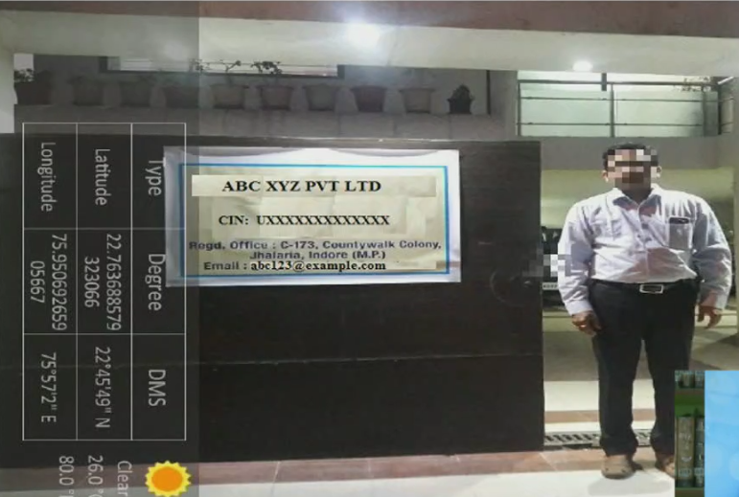

Q.25. In case the company has filed form GNL-2 prior to October 20, 2014 in respect of auditor’s appointment i.e. form ADT-1 as an attachment in form GNL-2, what is the remedy available?
In case the company has filed form GNL-2 in the period from April 1, 2014 to October 20, 2014 for intimation of auditor’s appointment, then companies are requested to refer the clarification issued by MCA. However, if clarification is not there, then they can raise ticket in such case.
Q.26. In case the company has filed form GNL-2 after October 20,2014 in respect of auditor’s appointment i.e. form ADT-1 as an attachment in form GNL-2, what is the remedy available?
In case the company has filed form GNL-2 after October 20, 2014 for intimation of auditor’s appointment, then companies are requested to file form ADT-1 with additional fees.
Q.27 (a). In case the company has not followed the uniform financial year as per section 2(41) of the Companies Act,2013 but has taken order from honorable CLB ( Company law Board), RD (Regional Director) & NCLT (National Company law tribunal ) in this regard, what is the remedy available to the company?
The Company in this case can raise the ticket to MCA and MCA may provide the solution on ticket to ticket basis. However, if the company has been allotted a time period by the honourable authorities, after the expiry of which they have to align with the uniform financial year, the company may do so as soon as possible.
Q.27 (b). What if the Company has not taken approval from CLB, RD and NCLT?
The Company is requested to raise the ticket to MCA and it’s advisable to take the prior approval from honorable CLB, RD and NCLT.
Q.28. Is it required to comply with the provisions of Section 12 of the Companies Act, 2013 for purpose of filing form INC-22 A?
Yes, due care should be taken in order to comply with the provisions of Section 12 of the Companies Act, 2013 for the purpose of filing this form.
Q.29. Is it mandatory to take the photograph in which latitude and longitude should be mentioned?
No it’s not mandatory that in the photograph, latitude and longitude should be mentioned. However, it is recommended or advisable the photograph should contain the latitude and longitude for the good corporate governance & better compliance purpose.
Q.30.The Company is in the process of shifting of registered office from one state to another and the order is still pending before RD, so will it be required to file this form or needs to wait till the order comes?
The Company is required to file the form in case the order is still pending before RD in case of shifting of registered office from one state to another.
Q.31. Whether the company which is active non-complaint can file the annual filing and charge related forms?
Yes, the company can file the annual filing and charge related forms in case the company is active non-complaint.
Q.32. Should the registered office name board to be in English and regional language as well?
As per Section 12(3)(a) of the Companies Act, 2013, every company shall paint or affix its name, and the address of its registered office, and keep the same painted or affixed, on the outside of every office or place in which its business is carried on, in a conspicuous position, in legible letters, and if the characters employed therefor are not those of the language or of one of the languages in general use in that locality, also in the characters of that language or of one of those languages.
Hence, it is advisable that Name board of the Company should be in English and in regional language in compliance with aforesaid provision.
Q.33. What should be done in case company has appointed more than maximum number of directors i.e. more than fifteen directors as prescribed in the Companies Act, 2013.
In case company has appointed more than fifteen directors, the Companies are advised to provide SRN of form MGT-14 filed in respect of appointing more than fifteen directors along with resolution date in the form.
Q.34.Is the Company required to appoint the minimum number of directors as prescribed in the Companies Act, 2013 for the purpose of filing this form?
Yes, the minimum prescribed limit of directors i.e. two in case of private company and three in case of public company should not be breached and directors need to appointed first for the purpose of meeting this compliance.
Q.35 Whether the DIR-3 KYC is to be filed before filing E-form (ACTIVE)?
Before filing E- form ACTIVE, the company needs to file DIR-3 KYC, so that the status of the Directors is “Approved”.

