

e-bulletin of Directorate of Student Services February, 2011
and Directorate of Academic & Professional Development

Directorate of Student Services

Part-I

Important Information for the months of
February, March & April 2011

Important cut-off dates:

1. Declaration of result of December : At 12.00 noon on Friday, 25th February 2011
2010 session examination Result will be available at institute’s website www.icsi.edu

2. Last date of submission of response : Monday, 28th February, 2011
sheets under Postal Tuition Scheme (Students are advised not to wait up to last date. They should
for students of Executive / Professional submit their response sheets at the earliest well in advance for
Program appearing in June 2011 exam timely processing & issuance of suggested answers)

3. Last date of registration for Executive : Monday, 28th February 2011
Program ( if student wishes to appear
in both modules of Executive Program
in December 2011 exam )

4. Last date of registration for Professional : Monday, 28th February 2011
Program ( if student wishes to appear
in all four modules of Professional Program
in December 2011 exam )

5. Last date for submission of examination
form for appearing in June 2011 exam : Friday, 25th March 2011
( without late fees )

6. Last date of admission to Foundation : Thursday, 31st March 2011
Program ( if student wishes to appear
in December 2011 exam )

7. Last date for submission of examination
form for appearing in June 2011 exam : Monday, 11th April 2011
( with late fees of ` 100/- ) ( 9th April & 10th April 2011 are being Saturday & Sunday )

Important points to be noted:

1. Recently three more examination centers ( i.e. Salem, Sonepat & Jabalpur ) have been opened, which will be operative since June 2011 examination onwards on experimental basis. Students residing in & around these places may avail the opportunity.

2. If any student wishes to apply for claiming exemption from any subject of Executive/ Professional Program on the basis of qualification, he/she is advised to submit his/her application for exemption ( along with a demand draft @ ` 100/- per subject and attested photocopies of mark sheets of all parts of relevant qualification) at the earliest to avoid last minutes complications.

3. If any student wishes to apply for extension of registration / or registration de-novo, he/she is advised to submit his/her application for extension of registration / or registration de-novo at the earliest.
De-novo / extension fees should never be clubbed with examination fees. Students are advised to apply for the same separately. They should also mention about the same in examination form at appropriate place.

4. Cancellation of Registration
Registration of students registered up to and including March 2006 stands terminated on expiry of five-year period on 28th February 2011 leading to the following immediate consequences :

(a) Supply of “Student Company Secretary” bulletin will be discontinued from March 2011 onwards.
(b) Response sheets will not be accepted even if submitted and coaching completion certificates will not be issued ( after the expiry of registration period ).

Important:

Students whose registration is valid up to February 2011 ( i.e. students registered in March 2006 ) are, however, eligible to appear in June 2011 examination without seeking extension of registration / registration de-novo subject to fulfilling other requirements as laid down in the regulations.

ATTENTION
Students of Final ( under old syllabus )

Regarding Compulsory switchover to New Syllabus

All students of Final who are presently pursuing the Company Secretaryship Course under old syllabus are hereby informed that from next examination onwards ( i.e. June 2011 session onwards ) institute’s examination will be conducted under new syllabus only.

As such all concerned students may note that w.e.f. 26th February 2011 all students who are presently in Final ( old syllabus ) will be compulsorily switched-over to Professional Program ( i.e. under new syllabus ).

Students who have already passed any subject of Final ( under old syllabus ) may note that they will be eligible for exemption in corresponding subjects under new
syllabus as per details mentioned below :

Sl No | FINAL ( old Syllabus ) | Subject Code | PROFESSIONAL PROGRAM  ( New Syllabus ) | Subject Code
1 | Advanced Company Law and Practice ( ACLP) | 131 | Company Secretarial Practice ( CSP) | 231
2 | Secretarial Practice relating to Eco. Laws and Drafting & Conveyancing ( SPRELDC) | 132 | Drafting, Appearances and Pleadings  ( DAP) | 232
3 | Secretarial, Management and System Audit ( SMSA) | 133 | Due Diligence & Corp. Compliance Mgt.  ( DDCCM) | 237
4 | Financial, Treasury and Forex Management ( FTFM) | 134 | Financial, Treasury and Forex Management ( FTFM) | 233
5 | Corporate Restructuring Law and Practice (CRLP) | 135 | Corporate Restructuring and Insolvency  ( CRI) | 234
6 | Banking and Insurance – Law and Practice ( BILP) | 136 | Governance, Business Ethics and Sustainability ( GBES) | 238
7 | WTO-International Trade,  Jt. Venture and Foreign Collaborations  ( WTO-ITJVFC) | 137 | Strategic Mgt, Alliances and International Trade ( SMAIT) | 235
8 | Direct and Indirect Taxation – Law and Practice ( DITLP) | 138 | Advanced Tax Law and Pracice ( ATLP) | 236
9 | Human Resources Mgt & Industrial Relations ( HRMIL) | 139 | Governance, Business Ethics and Sustainability ( GBES) | 238

Part-II

General Information students must know

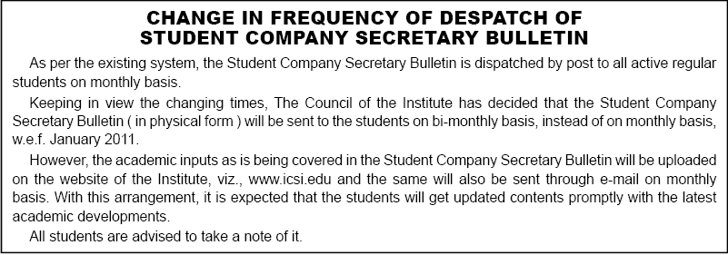

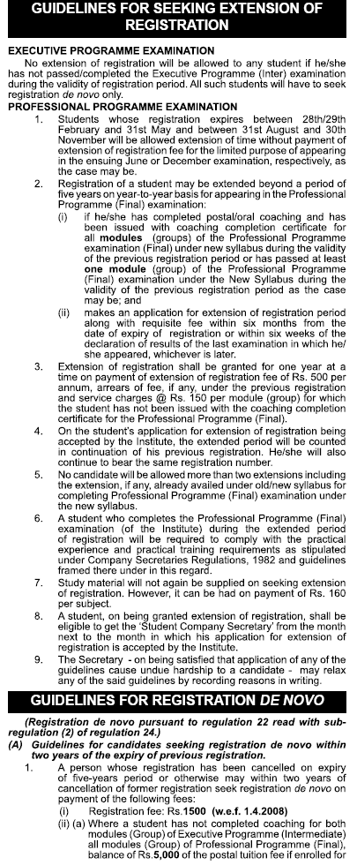
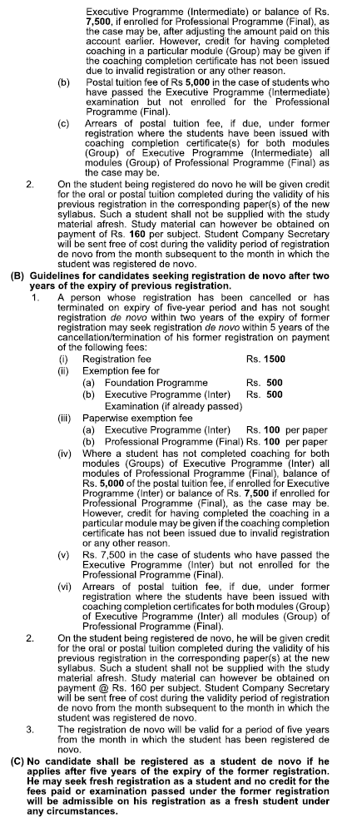
- Concession in Registration Fees / Examination Fees for Physically Handicapped Students:

- Change of Address
Change of address, if any, should be intimated to the Institute by sending a separate letter in this regard. While intimating the change in their mailing address, the students are advised to invariably quote the PIN CODE number along with the student registration number, name and full postal address with city, state in capital letters.
PIN CODE is required to be mentioned for quick delivery of the mail. Students may, therefore, check up the computerised mailing address as printed on the ‘Student Company Secretary’ bulletin. In case, it does not carry or carry the wrong PIN CODE number, the same may be intimated immediately quoting student registration number and full postal address with Postal Index Number so that it could be incorporated in the computerised mailing list.

- E-Mail Address of the Students
Those students who are having e-mail address may communicate the same to the Student Services Section (giving reference of their name & registration no.) at naveen.kumar@icsi.edu, which will facilitate quick and economic communication from the Institute’s side.

- Students Identity Card

All the students appearing in the examination must hold Identity Card in the manner prescribed by the Institute, if not already obtained at the time of seeking registration. For obtaining the Identity Card, students are advised to obtain a proforma from the Headquarters/Regional Offices of the Institute and send it again to the Institute duly filled up and attested as per instructions given in the prospectus/registration letter.

Students who have so far not obtained Identity Cards are advised to write to the Institute immediately. The students should carry their Identity Cards without fail for appearing in the Institute’s examination. If the Identity Card already issued has been lost or mutilated, student should send a request for obtaining duplicate Identity Card together with the mutilated Identity Card/Identity Card proforma duly filled in and attested together with Rs. 50/- towards duplicate Identity Card fee.

5. Compulsory Enrolment for Professional Programme.

Students who have passed/completed both modules of Executive examination are advised to seek compulsory enrolment for undergoing coaching for the Professional Programme on payment of Rs. 7500/- towards postal tuition fee.
Candidates will be admitted to the Professional Program examination, if : -

- He/She has registered himself/herself as a student for the Professional Programme at least nine calendar months prior to the month in which the examination commences. In other words, candidate registered as student up to and including the month of February in a year are eligible to appear in all the modules of the Professional Program examination to be held in December of that year, and those registered between March to August during a year are eligible to appear in all the four modules of the Professional Program examination to be held in the month of June next year subject to satisfactory completion of compulsory coaching.
- However, a candidate registered as a student at least six calendar months prior to the month in which the examination commences may be allowed to appear in any one or two module(s) of the Professional Program examination, that is to say, a candidate registered as a student up to and including the month of May in a year will be eligible for appearing in any one or two module(s) in December examination and those who are registered from June onwards and upto and including the month of November in a year will be eligible to appear in any one or two module(s) of Professional Program examination to be held in the month of June next year subject to satisfactory completion of compulsory coaching.

6. Uniformity in Signatures
It has been observed that some of the enrollment applications / letters received from the students are either unsigned or bear different signatures from time to time.

All the students are, therefore, advised to maintain uniformity in their signatures on all the correspondence with the Institute including students identity card, enrollment application and attendance sheet provided in the examination hall at the time of writing examinations.

7. Clarification Regarding Paperwise Exemption

(a) The paperwise exemption is granted only on the basis of specific request received in writing from a registered student along with the attested photocopies of marks sheets for all parts of the Degree/examination (on the basis of which the paperwise exemption is sought) and the exemption fee @ Rs. 100/- per paper. It is one time payment and not to be remitted for availing of paper wise exemption in every session of examination during the validity of registration period.

(b) The application for claiming paperwise exemption must reach the Institute on or before the last date for submission of enrolment application i.e. 25th March and 25th September for June and December examinations respectively and with a late fee of Rs. 100/-, the application can be accepted upto 9th April and 10th October respectively.

(c) The paperwise exemption once granted holds good during the validity of registration period or passing/completing the examination, whichever is earlier.

d) The paperwise exemption is cancelled only on receipt of a specific request in writing from the student concerned on or before the last date for submission of the enrolment application. If any candidate appears in the exempted paper(s) of examination without receiving the written confirmation from the Institute, but by making personal representation, appeal, request, etc., at the Examination Centre at the last moment, his/her appearance in such paper(s) shall automatically be treated as cancelled.

(e) It may be noted that candidates who apply for grant of paper wise exemption or seek cancellation of paper wise exemption already granted, before the last date of submission of enrolment applications for a particular examination, must see and ensure that they receive written confirmation from the Institute at least 15-20 days prior to the commencement of the examination. Candidates who would presume automatic grant or cancellation of paper wise exemption without obtaining written confirmation on time and absent themselves in any paper(s) of examination and/or appear in the exempted paper(s) would do so at their own risk and responsibility and the matter will be dealt with as per the above guidelines.

(f) Exemption once cancelled on request in writing shall not be granted again under any circumstances.

(g) The candidates who have passed either group of the Intermediate/Final examination under the old syllabus, may claim the paperwise exemption in the corresponding subject(s) of new syllabus indicating the basis of exemption as “APO” in the appropriate column of the enrolment application.

(h) In case the paperwise exemption has already been granted on the basis of qualification or the candidates is eligible for grant of exemption on the basis of securing 60% or more marks, a photocopy of the letter/marks-sheet issued by the Institute should be enclosed with the enrolment application while claiming such exemption, failing which the same may not be granted for the ensuing examination.

(i) No exemption fee is payable for availing paperwise exemption on the basis of “APO” or on the basis of securing 60% or more marks in the Institute’s examination.

(j) Paperwise exemption fee is payable only when the exemption is to be availed on the basis of qualification(s) specified for the purpose.

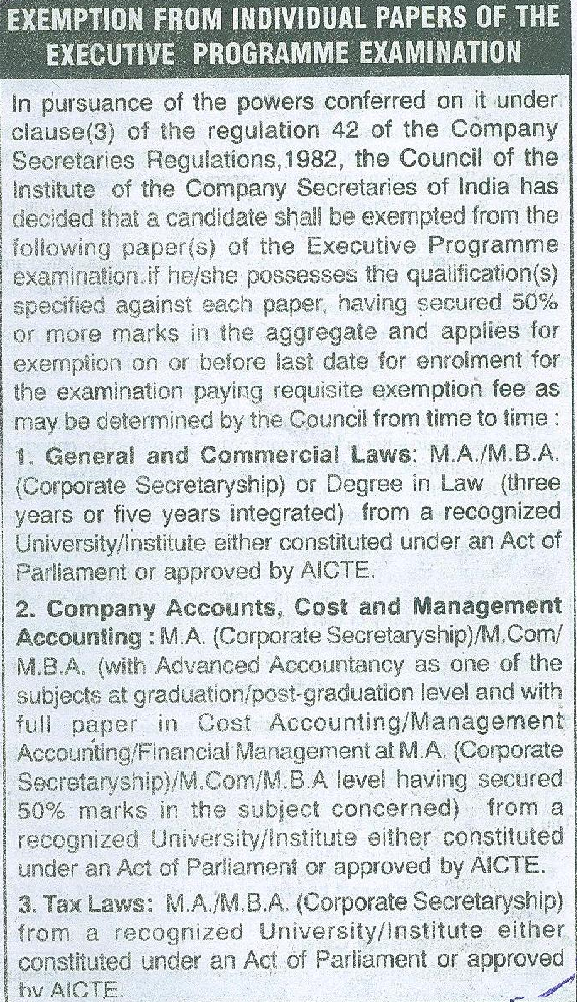

- Compulsory Computer Training

9. Student Induction Program (SIP)

Every candidate registered for the Executive Programme w.e.f. 01.09.2009 are required to undergo seven days Student Induction Programme (SIP) within 6 months of registration.

10. Exemption from Computer Training

A student shall be exempted from undergoing the course on the basis of he/she fulfill the following criteria:

- He/She has the requisite knowledge of the areas/topics covered in the computer training and
- He/She enrolls himself/ herself for an online exemption test (to be conducted by APTECH) at any of the APTECH Center on all India basis and successfully clears the test.

- Discontinuation of issue of pass certificates to Foundation / Executive Program pass students:

- Rationalization of system for issue of Coaching Completion Certificates under Postal Coaching Scheme:

- Schedule of Fees :

SCHEDULE OF FEES

PARTICULARS | FEES (Rs.) | REMARKS
FOUNDATION PROGRAMME
Admission Fee  Postal Tuition Fee | 1200  2400 | Total Fees → 3600
EXECUTIVE PROGRAMME (INTERMEDIATE)
Registration Fee  Foundation Examination Exemption Fee  Postal Tuition Fee for Executive Programme  Postal Tuition Fee for Foundation Programme (payable by Non-Commerce Graduates who are seeking exemption from passing the Foundation Programme Examination under clause (iii) of Regulation 38.)  Foundation Pass Student | 1500  500  5000 | Total Fees → 7000  (For commerce graduates)
 | 750  6500 | Total Fees → 7750  (For others)  Total Fees → 6500
PROFESSIONAL PROGRAMME (FINAL)
Postal Tuition Fee | 7500
DE-NOVO REGISTRATION
Registration De-Novo Fee | 1500
Exemption from Foundation Examination Fee | 500
Exemption from Executive Programme Examination Fee | 500
EXTENSION OF REGISTRATION
Extension of Registration Fee | 500
Service Charges for Extension of Registration | 150
EXAMINATION FEE
Foundation Programme | 875
Executive Programme | 900  (Per Module)
Professional Programme | 750  (Per Module)
Late Fee for receipt of Examination Application | 100
Change of Examination Center/Module/Medium | 100
For appearing from overseas Dubai Centre : Surcharge of US $ 100 in addition to the applicable examination fees.
OTHER FEES
Paper-wise Exemption Fee | 100
Issue of Duplicate Identity Card Fee | 50
Issue of Duplicate Pass Certificate Fee | 50
Issue of Duplicate Mark Sheet | 50
Issue of Transcript / certified copy of Syllabus | 100
Verification of Marks Fee | 100  (Per Subject)

- ICSI Students Education Fund Trust :

- Important Telephone Nos. of Directorate of Student Services :
Sl  No. | Nature of Query | Telephone  Numbers | E-mail IDs
1 | Issue of study materials | (0120) 4522061 | rajni.sharma@icsi.edu
2 | Registration Status of Foundation/Executive Program | (0120) 4522061 | ms.bhagwan@icsi.edu  (for Foundation Program) anju.gupta@icsi.edu  (for Executive Program)
3 | De-novo/ Extensión /Professional Enrolment | (0120) 4522072 | archana.goel@icsi.edu
4 | Paperwise Exemption | (0120) 4522074 | s.hemamalini@icsi.edu
5 | Non-receipt of Registration Letter/Identity Cards/Student Company Secretary Bulletin/E-mail Registration/Change of Address | (0120) 4522071 | naveen.kumar@icsi.edu
6 | Coaching Completion Certificates/ Suggested Answers and Response Sheets Status/ Examiners (DPTS) | (0120) 4522074 | sp.singh@icsi.edu
7 | Compulsory Computer Training | (0120) 4522075 | prem.lata@icsi.edu
8 | Public Private Partnership Scheme | (0120) 4522083 | ashvini.srivastava@icsi.edu
9 | Issue of Admission Certificate for Examinations | (0120) 4522085/87 | rahul.adhikari@icsi.edu
10 | Duplicate pass certificate of Final/Professional | (0120) 4522082 | rajesh.sharma@icsi.edu
11 | Transcript/Verification of Qualification (only for students) | (0120) 4522081/82 | siyaram@icsi.edu (for Executive Program) rajesh.sharma@icsi.edu (for Final/Professional Program)

- List of institutes empanelled for imparting Oral Coaching Classes to CS students Under Public Private Partnership Scheme of ICSI:
Name & Address |  | Validity for CS Session of Exam
EASTERN INDIA REGIONAL COUNCIL
M/s Happy Coaching Institute  Fatak, P.O. Budharaja  Sambalpur-768 004  Orissa |  | December`10 & June`11 Session of CS Examinations.
Proprietor  M/S Solution Education Centre  116, Gandhi Path,  North S K Puri  PATNA- 800013 |  | December`10 and June`11 Session of CS Examinations
Proprietor  M/S WISDOM Institute of Professional Learning,  3/100C, C R Colony,  On Raja S C Mallick Road  KOLKATA 700032 |  | December`10 and June`11 Session of CS Examinations
M/s Gyan Bharati Institute of Higher Studies, [Unit Gyan Bharati Society]  64A, Nimtalia Ghat Street,  KOLKATA 700 006 |  | June`11 and December`11 Session of CS Examinations
NORTHERN INDIA REGIONAL COUNCIL
M/s Springdale College of Management Studies  Madhotanda Road  Pilibhit-262 001 (U.P) | December`10 and June`11 Session of CS Examinations.
M/s Sainath Commerce Classes  C-20, Talwandi  KOTA-324 005 | December`10 and June`11 Session of CS Examinations.
M/s Lucknow Commerce Academy  S-72/17, Old `C` Block Chauraha  Rajajipuram (Near Lekhraj)  Lucknow-226 017 | Dec .10 Session and Jun’11 session of CS Examinations.
SAI INSTITUTE  Mallu Sarai,  SAMBHAL, Near Chamunda Mandir  MORADABAD | Dec .10 Session and Jun’11 session of CS Examinations.
The Director,  M/S G. S. Institute of Professional Studies,  Ahilya Bai Holkar Circle, Dampier Nagar  MATHURA [UP] | December ’10 and June’11 Session of C S Examination
The Director,  Commerce County-Institute for Commerce Studies, 137, Red Square Market,  Near Palki Hotel,  HISSAR – [Haryana} | December ’10 and June’11 Session of C S Examination
The Proprietor  M/S Brain Solutions,  ATS, Laxmi Bai Marg,  Aligarh [UP] | December ’10 and June’11 Session of C S Examination
The Director  M/S EKKISS,  1/5-B, EKKISS Road  Suratgarh, Dist Sri Ganganagar  RAJASTHAN | December ’10 and June’11 Session of C S Examination
Director,  M/s Advanced Commerce Study ,  14 Amar Complex, Dwarka More,  Uttam Nagar,  New Delhi 110059  Mob N0: 9818301515 | June`11 and December`11 Session of CS Examinations
Director,  M/s Govindam Business School,  514, Industrial Estate,  Patparganj  Delhi – 110092 | June`11 and December`11 Session of CS Examinations
MRS. SONIA GULATI  Proprietor, M/S CS Academy, House N0.35, 8, Maria Colony,  PANIPAT – [HARYANA] | June`11 and December`11 Session of CS Examinations
CA PRITAM K GOSWAMI  Director,M/S Career Institute of Commerce & Accounts [CICA] A-781, Near I L & Indra Vihar Joint,Indra Vihar,  KOTA- 324005 | June`11 and December`11 Session of CS Examinations
Mr Ajay Kumar Trivedi  M/S Vedanta Commerce Academy  C-28, Rajajipuram  LUCKNOW 226017 | June`11 and December`11 Session of CS Examinations
WESTERN INDIA REGIONAL COUNCIL
Senior Manager  M/s Career Classes  303, Shalimar Corporate Center  8, South Tukoganj  Near Hotel Balwas  Indore (M.P) |  | December`10 and June`11 Session of CS Examinations.
M/s Institute of Management Training & Research  Artha Complex, 2nd Floor  Near IMA House and Tapdiya Terrace, Off. Adalat Road  Aurangabad-431 001 (M.S) |  | June`11 and December`11 Session of CS Examinations.
The Principal  M/s D.M.`s College of Arts, Science & Commerce  Assagao, Bardez  GOA-403 507 |  | June`11 and December`11 Session of CS Examination.
M/s NAVKAR INSTITUTION  7, Pallavi Row House  Opp. Memnagar Fire Station  Navrangpura  Ahmedabad-380 009 |  | December`10 and June`11 Session of CS Examinations.
The Director  M/S Professional Excellence Academy  86, Zone-II, Third Floor,  M.P.Nagar  BHOPAL 462011 [MP] |  | December ’10 and June’11 Session of C S Examination
M/S Shri Gosar Hansraj Gosrani Commerce & Shri Dharamshi Devraj Nagda BBA College,Shah Bhagwanji Kachra Education Complex Near Octroi Post, Indira Gandhi Marg,  Jamnagar 351004 [Guj] |  | December ’10 and June’11 Session of C S Examination
The Director,  Professioinal Academy of Competitve Execellence[PACE],  B-402, 403, Silver Mall, R N T Marg,  Indore- 452001 [MP] |  | December ’10 and June’11 Session of C S Examination
Managing Director  Arihant Institute Pvt Ltd.,  “Arihant House”  2, Navin Park Society, Nr Muncipal School, Sardar Patel Colony Road,  Naran pura,  Ahmedabad – 380013 |  | June`11 and December`11 Session of CS Examinations
M/S Vrajesh Sir,s Academy of Commerce,  404/B, Swapneet-V  Near H L Commerce College,  Navrangpura  Ahmedabad 380009 |  | June`11 and December`11 Session of CS Examinations
Director  M/S Dnyanoday Corporte Training Centre N-11, E-11/3, Mayur Nagar  Hudco  Aurangabad 431136 |  | June`11 and December`11 Session of CS Examinations
SOUTHERN INDIA REGIONAL COUNCIL
M/s MOHANS Institute  Sreyas, Chettiparambil Lane  Thekkumbhagam,Tripunithura  Ernakulam (Distt.),  KERALA-682 301 |  | December`10 and June`11 Session of CS Examinations.
PRESIDENT,  M/s Dr. G.G. Shetty Educational Society ®  Jnana Degula , 25/B-4  Near K.M.F.  DHARWAD-580 004 |  | June` 11 and December`11 Session of CS Examination.
M/s Prize Academy  No.2, Teachers Colony  (Off V.M. Street)  Royapettah  Chennai-600 014 |  | December`10 and June`11 Session of CS Examination.
M/s Sree Saraswathi Thyagaraja College  Palani Road, Thippampatti  Coimbatore Distt.  POLLACHI-642 107 |  | December`10 and June`11 Session of CS Examination.
The Principal  M/s National College  Dindigul Road  Karumandapam  TIRUCHIRAPALLI-620 001 (T.N) |  | June`11 and December`11 Session of CS Examinations.
The Administrative Officer  M/s National Management College  2/16 Thudupathi, Perundurai  Erode [Dist] -638 057 |  | December`10 and June`11 Session of CS Examinations.
The Principal  M/s P.S.G.R. Krishnammal College  For Women  Peelamedu  COIMBATORE-641 004 |  | December’ 10 & June’11 Session of CS Examinations.
The Director  M/S Blue Dot Academy  N0.4, Balaji Avenue, Ist Street  T.Nagar  CHENNAI – 600017 |  | December ’10 and June ’11 session of C S examinations.
Managing Trustee  M/S Centre for Human Resources Development,Thekkel,Mannarakkayam PO ., Ponkunnam [via] Kanjirapally,  Kottayam Dist.,  KERALA – 686506 |  | December’10 and June ’11 session of C S examination.
The President  M/S Sengunthar Prudential Academy,  Erode Sengunthar Engineering College[Campus ] Thudupathi  ERODE – 638057 |  | December’10 and June ’11 session of C S examination
Director,  National Institute of Continuing Education  c/o S Srinivasan & C0. Corporate Services Pvt Ltd.,  No. 40/7, Ramakrishna street,  North Usman Road, T Nagar  Chennai 600017  Ph N0: 044-28141604 |  | December’10 and June ’11 session of C S examination
M/s Angel Auditor College, SF N0. 37, Marakkadai Street, Brindavan  Pudukottai 622001 |  | June`11 and December`11 Session of CS Examinations
Dr. Mohan Alva  M/S Alva Education Foundation  Alva’s College.  Sundari Anand Alva Campus  Vidyagiri, Moodbidri  Dakshina Kannada Dist  [Karnataka] |  | June`11 and December`11 Session of CS Examinations
MR. K N RAMASAMY,  Director, -Academics, RR Academy  N0.2, Noor Veerasamy Street, Off Vaalluvar Kottam High Road, Nungambakkam,  Chennai 600034 |  | June`11 and December`11 Session of CS Examinations
Principal  M/S Kathir College of Engineering  “Wisdom Tree”  S.F N0. 812/1, Neelambur  Coimbtore 641062 |  | June ’11 and December`11 Session of CS Examinations
Director,  PSG Institute of Management,  Post Box N0.1668,  Avinashi Road, Peelamedu  Coimbatore 641004 |  | June ’11 and December`11 Session of CS Examinations

Directorate of Academic & Professional Development

General Instruction :

In case of any specific problem / complaint regarding:

1. Registration, post registration, students services and postal / oral coaching, students may contact
personally or write to
Mr Sohan Lal
Director ( Student Services )
The Institute of Company Secretaries of India
C-37, Sector-62,
Noida-201309,
Tel : 0120-4522014 ( D )
e-mail : sohan.lal@icsi.edu.

2. Academic guidance and suggestions, if any, students may write to
Mr Sutanu Sinha
Director ( Academics )
The Institute of Company Secretaries of India
22, Institutional Area
Lodi Road
New Delhi-110003
Tel : 011-45341014 (D)
e-mail : sutanu.sinha@icsi.edu.

