

e-bulletin of Directorate of Student Services January 2011

Directorate of Student Services

Part-I

Important Information for the months of
January, February & March 2011

Important cut-off dates:

1. Last date of submission of response : Monday, 17th January 2011
sheets under Postal Tuition Scheme ( 15th & 16th January 2011 being officially off-day )
for students of Foundation Program (Students are advised not to wait up to last date. They should
appearing in June 2011 exam submit their response sheets at the earliest well in advance for
timely processing & issuance of suggested answers)

2. Declaration of result of December : At 12.00 noon on Friday, 25th February 2011
2010 session examination Result will be available at institute’s website www.icsi.edu

3. Last date of submission of response : Monday, 28th February, 2011
sheets under Postal Tuition Scheme (Students are advised not to wait up to last date. They should
for students of Executive / Professional submit their response sheets at the earliest well in advance for
Program appearing in June 2011 exam timely processing & issuance of suggested answers)

4. Last date of registration for Executive : Monday, 28th February 2011
Program ( if student wishes to appear
in both modules of Executive Program
in December 2011 exam )

5. Last date of registration for Professional : Monday, 28th February 2011
Program ( if student wishes to appear
in all four modules of Professional Program
in December 2011 exam )

6. Last date for submission of examination
form for appearing in June 2011 exam : Friday, 25th March 2011
( without late fees )

7. Last date of admission to Foundation : Thursday, 31st March 2011
Program ( if student wishes to appear
in December 2011 exam )

Important points to be noted:

1. If any student wishes to apply for claiming exemption from any subject of Executive/ Professional Program on the basis of qualification, he/she is advised to submit his/her application for exemption ( along with a demand draft @ ` 100/- per subject and attested photocopies of mark sheets of all parts of relevant qualification) at the earliest to avoid last minutes complications.

2. If any student wishes to apply for extension of registration / or registration de-novo, he/she is advised to submit his/her application for extension of registration / or registration de-novo at the earliest.
De-novo / extension fees should never be clubbed with examination fees. Students are advised to apply for the same separately. They should also mention about the same in examination form at appropriate place.

3. Cancellation of Registration
Registration of students registered up to and including February 2006 stands terminated on expiry of five-year period on 31st January 2011 leading to the following immediate consequences :

(a) Supply of “Student Company Secretary” bulletin will be discontinued from February 2011 onwards.
(b) Response sheets will not be accepted even if submitted and coaching completion certificates will not be issued ( after the expiry of registration period ).
(c) They are not allowed to submit the examination form for June 2011 exam. They are advised to apply for registration de-novo / extension of registration as per the guidelines of the institute.

Important:

Students whose registration is valid up to February 2011 ( i.e. students registered in March 2006 ) are, however, eligible to appear in June 2011 examination without seeking extension of registration / registration de-novo subject to fulfilling other requirements as laid down in the regulations.

Part-II

General Information students must know

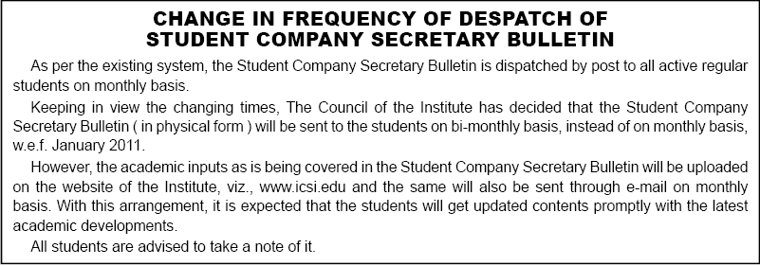

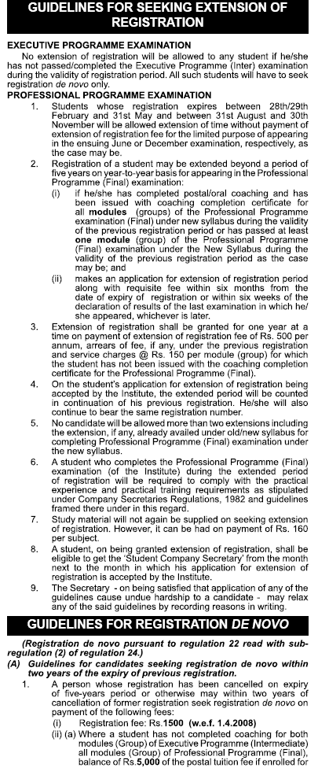
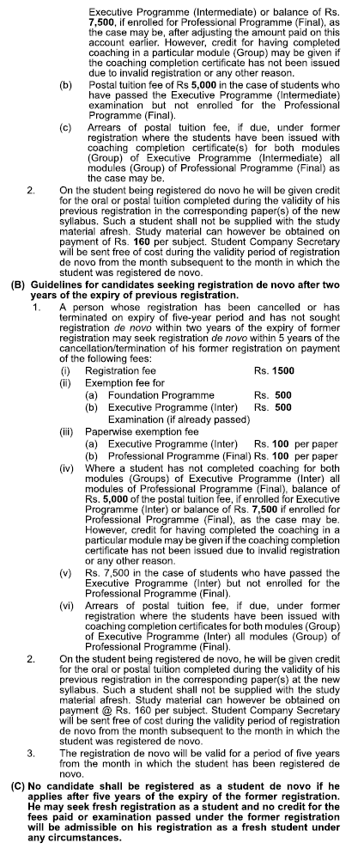
- Concession in Registration Fees / Examination Fees for Physically Handicapped Students:

- Change of Address
Change of address, if any, should be intimated to the Institute by sending a separate letter in this regard. While intimating the change in their mailing address, the students are advised to invariably quote the PIN CODE number along with the student registration number, name and full postal address with city, state in capital letters.
PIN CODE is required to be mentioned for quick delivery of the mail. Students may, therefore, check up the computerised mailing address as printed on the ‘Student Company Secretary’ bulletin. In case, it does not carry or carry the wrong PIN CODE number, the same may be intimated immediately quoting student registration number and full postal address with Postal Index Number so that it could be incorporated in the computerised mailing list.

- E-Mail Address of the Students
Those students who are having e-mail address may communicate the same to the Student Services Section (giving reference of their name & registration no.) at naveen.kumar@icsi.edu, which will facilitate quick and economic communication from the Institute’s side.

- Students Identity Card

All the students appearing in the examination must hold Identity Card in the manner prescribed by the Institute, if not already obtained at the time of seeking registration. For obtaining the Identity Card, students are advised to obtain a proforma from the Headquarters/Regional Offices of the Institute and send it again to the Institute duly filled up and attested as per instructions given in the prospectus/registration letter.

Students who have so far not obtained Identity Cards are advised to write to the Institute immediately. The students should carry their Identity Cards without fail for appearing in the Institute’s examination. If the Identity Card already issued has been lost or mutilated, student should send a request for obtaining duplicate Identity Card together with the mutilated Identity Card/Identity Card proforma duly filled in and attested together with Rs. 50/- towards duplicate Identity Card fee.

5. Compulsory Enrolment for Professional Programme.

Students who have passed/completed both modules of Executive examination are advised to seek compulsory enrolment for undergoing coaching for the Professional Programme on payment of Rs. 7500/- towards postal tuition fee.
Candidates will be admitted to the Professional Program examination, if : -

- He/She has registered himself/herself as a student for the Professional Programme at least nine calendar months prior to the month in which the examination commences. In other words, candidate registered as student up to and including the month of February in a year are eligible to appear in all the modules of the Professional Program examination to be held in December of that year, and those registered between March to August during a year are eligible to appear in all the four modules of the Professional Program examination to be held in the month of June next year subject to satisfactory completion of compulsory coaching.
- However, a candidate registered as a student at least six calendar months prior to the month in which the examination commences may be allowed to appear in any one or two module(s) of the Professional Program examination, that is to say, a candidate registered as a student up to and including the month of May in a year will be eligible for appearing in any one or two module(s) in December examination and those who are registered from June onwards and upto and including the month of November in a year will be eligible to appear in any one or two module(s) of Professional Program examination to be held in the month of June next year subject to satisfactory completion of compulsory coaching.

6. Uniformity in Signatures
It has been observed that some of the enrollment applications / letters received from the students are either unsigned or bear different signatures from time to time.

All the students are, therefore, advised to maintain uniformity in their signatures on all the correspondence with the Institute including students identity card, enrollment application and attendance sheet provided in the examination hall at the time of writing examinations.

7. Clarification Regarding Paperwise Exemption

(a) The paperwise exemption is granted only on the basis of specific request received in writing from a registered student along with the attested photocopies of marks sheets for all parts of the Degree/examination (on the basis of which the paperwise exemption is sought) and the exemption fee @ Rs. 100/- per paper. It is one time payment and not to be remitted for availing of paper wise exemption in every session of examination during the validity of registration period.

(b) The application for claiming paperwise exemption must reach the Institute on or before the last date for submission of enrolment application i.e. 25th March and 25th September for June and December examinations respectively and with a late fee of Rs. 100/-, the application can be accepted upto 9th April and 10th October respectively.

(c) The paperwise exemption once granted holds good during the validity of registration period or passing/completing the examination, whichever is earlier.

d) The paperwise exemption is cancelled only on receipt of a specific request in writing from the student concerned on or before the last date for submission of the enrolment application. If any candidate appears in the exempted paper(s) of examination without receiving the written confirmation from the Institute, but by making personal representation, appeal, request, etc., at the Examination Centre at the last moment, his/her appearance in such paper(s) shall automatically be treated as cancelled.

(e) It may be noted that candidates who apply for grant of paper wise exemption or seek cancellation of paper wise exemption already granted, before the last date of submission of enrolment applications for a particular examination, must see and ensure that they receive written confirmation from the Institute at least 15-20 days prior to the commencement of the examination. Candidates who would presume automatic grant or cancellation of paper wise exemption without obtaining written confirmation on time and absent themselves in any paper(s) of examination and/or appear in the exempted paper(s) would do so at their own risk and responsibility and the matter will be dealt with as per the above guidelines.

(f) Exemption once cancelled on request in writing shall not be granted again under any circumstances.

(g) The candidates who have passed either group of the Intermediate/Final examination under the old syllabus, may claim the paperwise exemption in the corresponding subject(s) of new syllabus indicating the basis of exemption as “APO” in the appropriate column of the enrolment application.

(h) In case the paperwise exemption has already been granted on the basis of qualification or the candidates is eligible for grant of exemption on the basis of securing 60% or more marks, a photocopy of the letter/marks-sheet issued by the Institute should be enclosed with the enrolment application while claiming such exemption, failing which the same may not be granted for the ensuing examination.

(i) No exemption fee is payable for availing paperwise exemption on the basis of “APO” or on the basis of securing 60% or more marks in the Institute’s examination.

(j) Paperwise exemption fee is payable only when the exemption is to be availed on the basis of qualification(s) specified for the purpose.

- Compulsory Computer Training

9. Student Induction Program (SIP)

Every candidate registered for the Executive Programme w.e.f. 01.09.2009 are required to undergo seven days Student Induction Programme (SIP) within 6 months of registration.

10. Exemption from Computer Training

A student shall be exempted from undergoing the course on the basis of he/she fulfill the following criteria:

- He/She has the requisite knowledge of the areas/topics covered in the computer training and
- He/She enrolls himself/ herself for an online exemption test (to be conducted by APTECH) at any of the APTECH Center on all India basis and successfully clears the test.

- Discontinuation of issue of pass certificates to Foundation / Executive Program pass students:

- Rationalization of system for issue of Coaching Completion Certificates under Postal Coaching Scheme:

- Schedule of Fees :

- ICSI Students Education Fund Trust :

15. Important Telephone Nos. of Directorate of Student Services :

16. List of institutes empanelled for imparting Oral Coaching Classes to CS students Under Public Private Partnership Scheme of ICSI:

General Instruction :

In case of any specific problem / complaint regarding:

1. Registration, post registration, students services and postal / oral coaching, students may contact personally or write to
Mr Sohan Lal
Director ( Student Services )
The Institute of Company Secretaries of India
C-37, Sector-62,
Noida-201309,
Tel : 0120-4522014 ( D )
e-mail : sohan.lal@icsi.edu.

2. Academic guidance and suggestions, if any, students may write to
Mr Sutanu Sinha
Director ( Academics )
The Institute of Company Secretaries of India
22, Institutional Area
Lodi Road
New Delhi-110003
Tel : 011-45341014 (D)
e-mail : sutanu.sinha@icsi.edu.

******************

