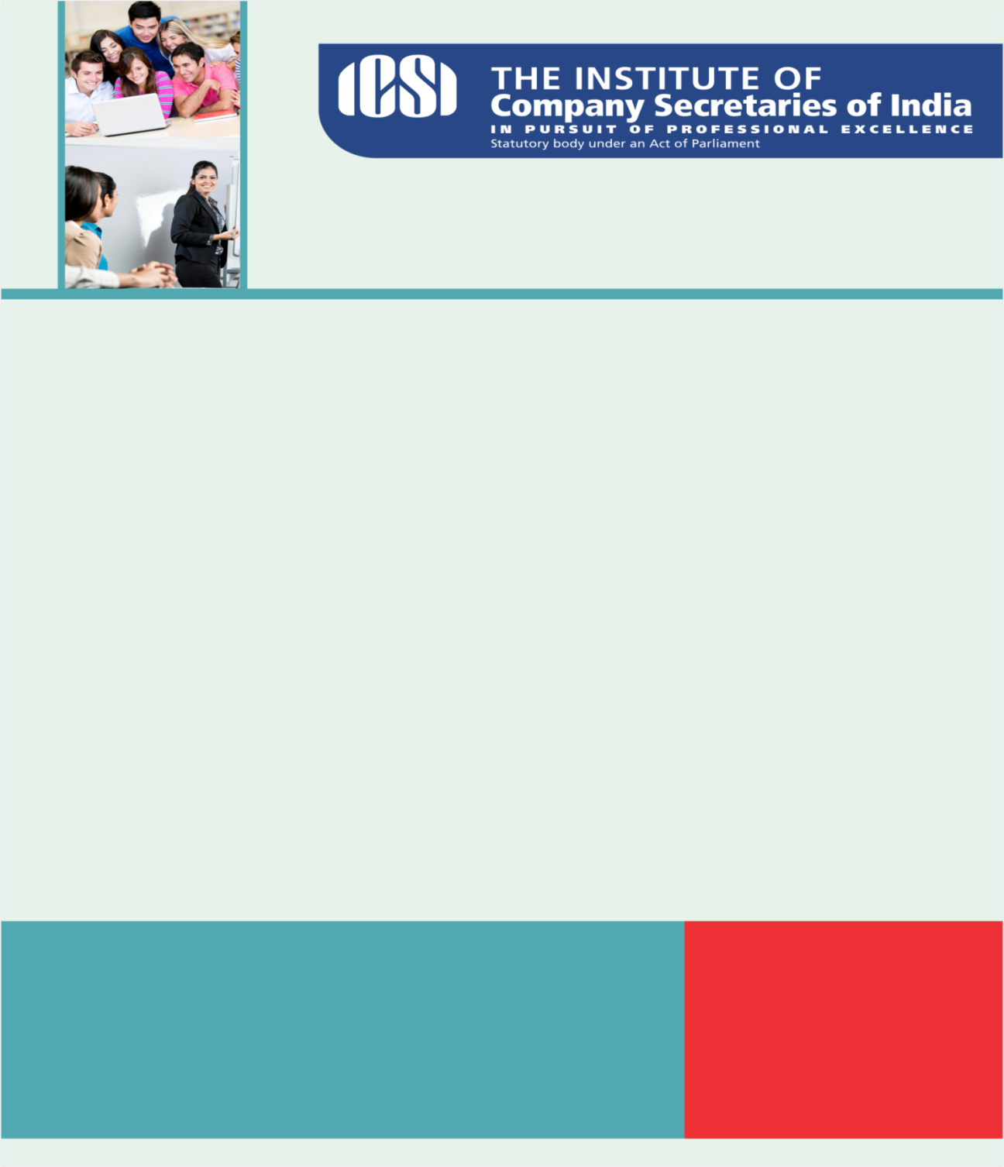

**OCTOBER 4, 2016**

“When the wind blows there are those that build walls and then there are those that build windmills..”

**Knowledge Appraise**

* + - * [News Headlines](https://www.icsi.edu/Docs/Webmodules/NEWS%20HIGHLIGHTS.pdf)
      * SEBI: [August 2016 Bulletin](http://www.sebi.gov.in/cms/sebi_data/attachdocs/1475491676247.pdf)
      * [Duties Defined and Duties Performed: A Gap Analysis of Directors’ Duties in Small and Medium size Enterprises, Punjab, by University Business School, Panjab University, Chandigarh: 2016](http://www.nfcgindia.org/UBS_punjab_university_duties_defined_duties_performed_a_gap_analysis_of_directors_duties.html)
      * [Research on Debt, Defaults, and Corporate Governance, by IIM Bangalore: 2016](http://www.nfcgindia.org/IIMB_research_on_debts_defaults_and_corproate_governance.html)
      * [Does Good Corporate Governance lead to Enhanced Business Value? by International Management Institute, Kolkata: 2016](http://www.nfcgindia.org/IMIK_final_research_report_NFCG_mar_2016.html)

**Regulatory Updates**

* + - MCA: [MCA has taken another bold initiative in Government Process Re-engineering (GPR) and launched Simplified proforma for Incorporating Company Electronically (SPICe) e-Form](http://www.mca.gov.in/Ministry/pdf/SPICEPress%20Release_03102016.pdf)
    - RBI:
      * [Investment by Foreign Portfolio Investors (FPI) in Government Securities (Revised)](https://www.rbi.org.in/Scripts/NotificationUser.aspx?Id=10623&Mode=0)
      * [Master Direction - Monitoring of Frauds in NBFCs (Reserve Bank) Directions, 2016](https://www.rbi.org.in/Scripts/NotificationUser.aspx?Id=10622&Mode=0)
      * [Master Direction - Non-Banking Financial Companies Auditor’s Report (Reserve Bank) Directions, 2016](https://www.rbi.org.in/Scripts/NotificationUser.aspx?Id=10621&Mode=0)
      * [Master Direction- Non-Banking Financial Company Returns (Reserve Bank) Directions, 2016](https://www.rbi.org.in/Scripts/NotificationUser.aspx?Id=10620&Mode=0)
      * [Publishing of photographs of Wilful defaulters](https://www.rbi.org.in/Scripts/NotificationUser.aspx?Id=10619&Mode=0)
      * [Aadhaar-based Authentication for Card Present Transactions](https://www.rbi.org.in/Scripts/NotificationUser.aspx?Id=10618&Mode=0)
      * [Grant of ‘Certificate of Registration’ – For carrying on the business of Credit Information – Transunion CIBIL Limited](https://www.rbi.org.in/Scripts/NotificationUser.aspx?Id=10617&Mode=0)
      * [Master Circular- Credit Facilities to Minority Communities – Modification](https://www.rbi.org.in/Scripts/NotificationUser.aspx?Id=10615&Mode=0)
      * [Doubling Farmers’ Income by 2022’ - Measures](https://www.rbi.org.in/Scripts/NotificationUser.aspx?Id=10614&Mode=0)
    - SEBI:  [[Investments by FPIs in Government securities](javascript:%20popUp('http://www.sebi.gov.in/cms/sebi_data/attachdocs/1475498739311.pdf');)](http://www.sebi.gov.in/cms/sebi_data/pdffiles/34869_t.pdf)

***ICSI News***

* + - [PHD GST Knowledge Series - Draft GST Rules/ Formats & Supply and Time/ Place of Supply & Valuation of Goods & Services](https://www.icsi.edu/webmodules/GOODS_SERVICES_TAX.pdf)
    - [The Financial Resolution and Deposit Insurance Bill, 2016](https://www.icsi.edu/webmodules/FRDI_Bill-27092016.pdf)
    - [Celebration of 48th CS Day at Gorky Sadan, Kolkata on 4th October, 2016](https://www.icsi.edu/webmodules/CSDAY_FLYER_MATTER.pdf)
    - [FAQs on GST Announcement](https://www.icsi.edu/webmodules/GSTHeadlines/FAQs_on_GST_Announcement.pdf)
    - [44th National Convention Brochure](https://www.icsi.edu/webmodules/44th_Convention.pdf)
    - [Inviting Participation- 16th ICSI National Awards For Excellence in Corporate Governance, 2016 ; 1st ICSI CSR Excellence Awards.](https://www.icsi.edu/webmodules/CG_CSR_Awards.pdf)   
      Final Questionnaire for corporate governance [*click here*](https://www.icsi.edu/webmodules/Final_Questionnaire_1092016.docx) ICSI CSR Awards Questionnaire 2016 [*click here*](https://www.icsi.edu/webmodules/ICSI_CSR_Awards_Questionnaire2016.docx)
    - [ICSI Invites International Research Papers for its Global Congruence on International Corporate Governance Day To be Held on 09 & 10 December 2016 @ Hyderabad, Telangana, India](https://www.icsi.edu/Docs/Webmodules/Research_Paper_submission_Jul222016.pdf)

**Legal Term**

*“Ignorantia legis neminem* *excusat”*

Ignorance of law excuses no one.

*Kindly send your feedback/suggestions regarding CS updates at* [*csupdate@icsi.edu*](mailto:csupdate@icsi.edu)

**For Previous CS UPDATE(S) visit :** <http://www.icsi.edu/Member/CSUpdate.aspx>

If you are not receiving the CS update, kindly update your e-mail id with Institute’s database by logging on ICSI website.